**SQL basic**

**SQL basic Outlines**

* **Create Table (DDL)**
* **Drop (Delete) Table (DDL)**
* **ALTER Table (DDL)**
* **DELETE Command (DDL)**
* **TRUNCATE Command (DDL)**
* **UPDATE Command (DML)**
* **Comparison Conditions** 
  + =, > , >=, < , <=
  + BETWEEN ... AND …
  + IN (Set)
  + LIKE
* **Logical Conditions** 
  + AND
  + OR
  + NOT
* **Arithmetic Expressions on columns numeric data**
* **ORDER BY Clause (ASC, DESC)**
* **GROUP BY with HAVING Clause**

### 

### [**DB_part1.sql**](https://drive.google.com/file/d/13p9uKbRe7OLAC2Zrm7TN_uRIWqV5-_mh/view?usp=sharing) **Link**

<https://drive.google.com/file/d/13p9uKbRe7OLAC2Zrm7TN_uRIWqV5-_mh/view?usp=sharing>

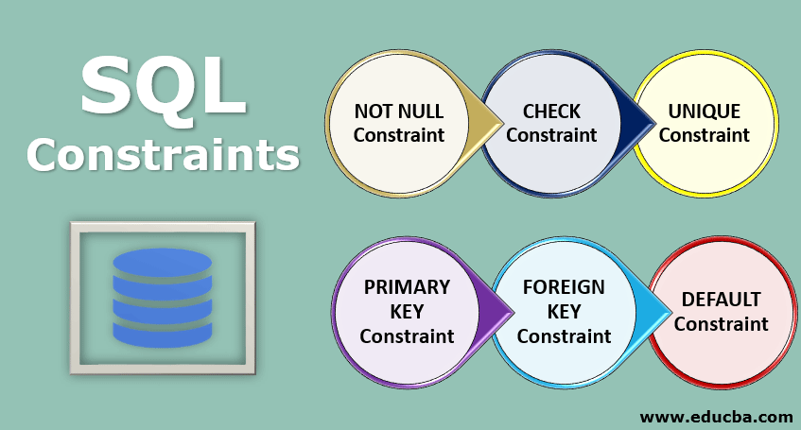

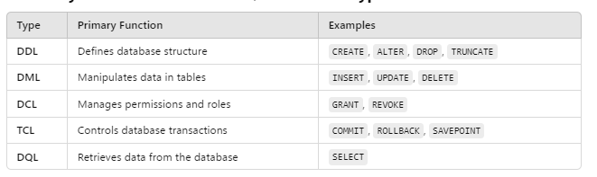

**Drop (Delete) Table (DDL)**

To drop the users table, you can use the following SQL command:

DROP TABLE [Table Name];

Eg:

DROP TABLE users;

**ALTER Command (DDL)**

The ALTER DDL command is used to modify the structure of an existing table.

Here are some examples of common ALTER operations for the users table:

* 1. Add a New Column (ADD word)

Syntax:

ALTER TABLE table_name

**ADD** COLUMN column_name data_type constraints;

Eg:

ALTER TABLE users ADD COLUMN phone VARCHAR(15);

ALTER TABLE users ADD COLUMN phone1 varchar(20) NOT null;

* 2. Modify an Existing Column

Syntax:

ALTER TABLE table_name MODIFY COLUMN column_name new_data_type constraints;

Eg:

ALTER TABLE users MODIFY COLUMN phone VARCHAR(15) **DEFAULT 'Not Provided'**;

Eg:

ALTER TABLE users

MODIFY COLUMN name VARCHAR(100) NOT NULL;

Eg:

ALTER TABLE users

MODIFY COLUMN id INT **AUTO_INCREMENT** **PRIMARY KEY**;

* 3. Rename a Column

Syntax:

ALTER TABLE table_name

CHANGE COLUMN old_column_name new_column_name data_type constraints;

Eg:

ALTER TABLE users CHANGE COLUMN email user_email VARCHAR(255) **NOT NULL**;

* 4. Drop a Column

Syntax:

ALTER TABLE table_name

DROP COLUMN column_name;

Eg:

ALTER TABLE users DROP COLUMN phone;

* **5. Add a Constraint**

Syntax:

ALTER TABLE table_name

ADD CONSTRAINT constraint_name constraint_type(column_name);

Eg:

ALTER TABLE users

ADD CONSTRAINT unique_email **UNIQUE(email)**;

* **6. Rename the Table**

Syntax:

ALTER TABLE table_name

RENAME TO new_table_name

Eg:

ALTER TABLE users RENAME TO customers;

**UPDATE Command (DML)**

The **UPDATE** command is used to modify existing records in a table.

Syntax:

UPDATE table_name

SET column1 = value1, column2 = value2, ...

WHERE condition;

Eg: Update a Single Column

UPDATE users

SET email = 'updated.email@example.com'

WHERE id = 3;

Eg: Update Multiple Column

UPDATE users

SET name = 'Alice Johnson', email = 'alice.johnson@example.com'

WHERE id = 4;

**DELETE Command Examples**

The **DELETE** command is used to remove rows from a table. Without resetting for any AUTO_INCREMENT counter

Syntax:

DELETE FROM table_name

WHERE condition;

Eg1: Delete a Specific Row

DELETE FROM orders

WHERE order_id = 5;

Eg2: Delete All Rows (without Dropping Table)

DELETE FROM orders;

**TRUNCATE Command**

The TRUNCATE command is used to quickly remove all rows from a table while resetting any AUTO_INCREMENT counters.

TRUNCATE TABLE table_name;

* For example:
  + Deletes all rows from the users table and resets the id column's AUTO_INCREMENT counter.
  + TRUNCATE TABLE orders;

### **Key Differences: DELETE vs. TRUNCATE**

| **Feature** | **DELETE** | **TRUNCATE** |
| --- | --- | --- |
| Deletes Specific Rows? | Yes (with WHERE clause). | No, deletes all rows. |
| Resets AUTO_INCREMENT? | No. | Yes. |
| Speed | Slower, logs individual row deletions. | Faster, no row-by-row logging. |

**Task Part 1: SQL Practice with ALTER and UPDATE Command**

**END AT 8:40 PM**

### **ALTER TABLE**

1. Add a new column birth_date of type DATE to the employees table.
2. Change the data type of the order_total column in the orders table to DECIMAL(12,2).
3. Rename the column job_title in the employees table to position_title (VARCHAR(255)).

### **🔹 UPDATE**

4. Increase the order_total in the orders table by 5% for all orders placed after '2024-01-17'.  
 UPDATE orders

SET order_total = order_total * 1.05

WHERE order_date > STR_TO_DATE('17-01-2024', '%d-%m-%Y');

**🔹 DELETE**

5. Delete all employees in the employees table who work in the Support department.

6. Delete all orders from the orders table where order_total is less than 200.

**7. “After completing the tasks, drop all tables and then import the SQL file again.”**

### **Comparison Conditions Explanation**

Here’s a detailed explanation of each comparison condition with a description, syntax, and examples:

### **1) =, > , >=, < , <=**

Syntax:

column_name = value

Eg1: Retrieves all rows where the name is Ahmed Ali.

SELECT * FROM users WHERE name = 'Ahmed Ali';

Eg2: Retrieves employees earning more than 5000.

SELECT * FROM employees WHERE salary >= 5000;

### **2) BETWEEN ... AND …**

Description: Checks if a column value is within a specified range, inclusive of the boundary values.

Syntax:

column_name BETWEEN value1 AND value2

Eg1: Retrieves employees whose salaries are between 4000 and 6000, inclusive.

SELECT * FROM employees

WHERE salary BETWEEN 4000 AND 6000;

Eg2: Retrieves employees hired in the year 2024.

SELECT * FROM employees

WHERE hire_date

BETWEEN '2024-01-01' AND '2024-12-31';

### 

### 

### 

### 

### 

### **3) IN (Set)**

Description: Checks if a column value matches any value in a specified list.

Syntax:

column_name IN (value1, value2, ...)

Eg1: Retrieves employees who are either Software Engineer or Data Analyst.

SELECT * FROM employees

WHERE job_title IN ('Software Engineer', 'Data Analyst');

Eg2: Retrieves users with names Ahmed Ali, Layla Sami, or Omar Adel.

SELECT * FROM users

WHERE name IN ('Ahmed Ali', 'Layla Sami', 'Omar Adel');

### **4) LIKE**

Description: Matches a value to a specified character **pattern using wildcards.**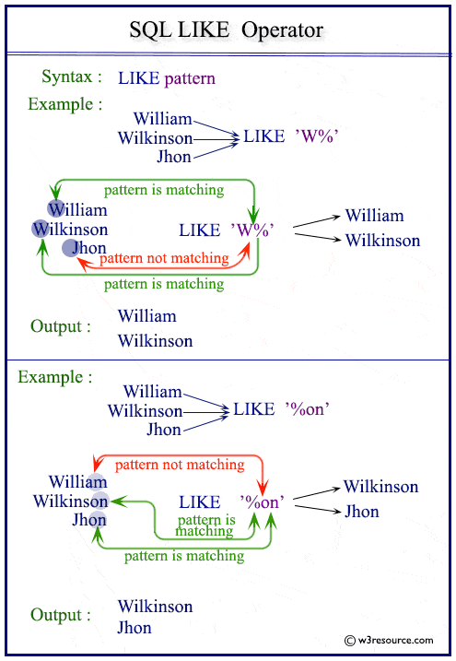

Syntax:

column_name LIKE 'pattern'

Wildcards:

%: Matches any sequence of characters.

_: Matches exactly one character.

Eg1: Retrieves users whose names start with A.

SELECT * FROM users

WHERE name LIKE 'A%';

Eg2: Retrieves employees whose job title ends with Engineer.

SELECT * FROM employees

WHERE job_title LIKE '%Engineer';

Eg3: Find Users Whose Names Start with Any Single Character Followed by hmed

SELECT * FROM users

WHERE name LIKE '_hmed%';

### **Logical Conditions Explanation**

Logical conditions in SQL are used to combine multiple conditions in a query. The most common logical operators are AND, OR, and NOT.

### **1. AND**

* Description: Combines two or more conditions and returns rows only when all conditions are true.  
  Syntax:   
  condition1 AND condition2

Eg1: Retrieves employees in the IT department with a salary greater than 5300.

SELECT * FROM employees

WHERE department = 'IT' AND salary > 5300;

Eg2: Retrieves users whose names start with A **and** emails belong to @gmail.com.

SELECT * FROM users

WHERE name LIKE 'A%' AND email LIKE '%@example.com';

### **2. OR**

* Description: Combines two or more conditions and returns rows when at least one condition is true.  
  Eg1: Retrieves employees who are in either the IT or HR department.  
  SELECT * FROM employees  
  WHERE department = 'IT' OR department = 'HR';

Eg2: Retrieves users whose names start with F or whose emails end with .com.

SELECT * FROM users

WHERE name LIKE 'F%' OR email LIKE '%.com';

Eg3: Retrieves employees who are in the IT or HR department and have a salary greater than 5300.

SELECT * FROM employees

WHERE (department = 'IT' OR department = 'HR') AND salary > 5300;

Eg3: Find Employees in Non-IT Departments

SELECT * FROM employees WHERE NOT department = 'IT';

### **Arithmetic Expressions in SQL**

#### **Description**

Arithmetic expressions are used to perform mathematical operations on numeric data in SQL. Supported operators include:

* + (Addition)
* - (Subtraction)
* * (Multiplication)
* / (Division)
* % (Modulo, remainder after division)

SELECT column_name, column_name [arithmetic_expression] AS alias_name

FROM table_name;

Eg1: Calculate Total Salary with Bonus

Adds a bonus of 500 to each employee’s salary and returns the total.

SELECT employee_id, salary,

(salary + 500) AS total_salary

FROM employees;

Eg2: Calculate Annual Salary

Multiplies the monthly salary by 12 to compute the annual salary.

SELECT employee_id, salary, (salary * 12) AS annual_salary FROM employees;

### 

### ORDER BY **Clause (ASC, DESC)**

#### **Description**

The ORDER BY clause is used to sort the query result based on one or more columns. The sorting can be in:

* ASC (Ascending order, default): Smallest to largest.
* DESC (Descending order): Largest to smallest.

SELECT column1, column2

FROM table_name

ORDER BY column_name [ASC|DESC];

Eg1: Retrieves employees sorted by salary from the lowest to the highest.

SELECT employee_id, job_title, salary

FROM employees

ORDER BY salary ASC;

Eg2: Sort Users Alphabetically by Name

SELECT id, name, email

FROM users

ORDER BY name ASC;

Eg3: Sort by Multiple Columns

SELECT employee_id, department, salary FROM employees

ORDER BY department ASC, salary DESC;

### **GROUP BY Clause in SQL**

#### **Description**

The GROUP BY clause is used to aggregate rows with the same values in specified columns into summary rows, like calculating totals, averages, counts, etc. It is often used with **aggregate functions** such as:

* COUNT()
* SUM()
* AVG()
* MAX()
* MIN()

#### **Syntax**

Select “picks the columns”

from “picks the table(s)”

group by “selected column(s)”

having “impose a condition”;

**Example 1: Counts the number of employees in each department.**

SELECT department, COUNT(*) AS employee_count

FROM employees

GROUP BY department;

**Example 2: Calculate Average Salary Per Department**

SELECT department, AVG(salary) AS average_salary

FROM employees

GROUP BY department;

#### **Example 3: Find the Total Salary Paid in Each Department**

SELECT department, SUM(salary) AS total_salary

FROM employees

GROUP BY department;

### **GROUP BY with HAVING Clause**

The HAVING clause is used to filter groups based on aggregate conditions (similar to WHERE but for aggregated data).

**Example: Departments with More Than 1 Employee**

SELECT department, COUNT(*) AS employee_count

FROM employees

GROUP BY department

HAVING COUNT(*) > 1;

* Explanation: Only returns departments that have more than one employee.

**Task #2 on Comparison, Filtering, and Aggregation**

## **🔹 Level 1 → Basic Queries**

1. Select all employees from the employees table whose **salary is greater than 5000**.
2. Select all orders from the orders table where the **order_total is between 200 and 400**.
3. Get employees with a **salary greater than or equal to 4500 but less than 6000**.
4. Select all users from the users table whose **email contains "gmail"** (use **LIKE**).

## **🔹 Level 2 – Conditional & Filtering Queries**

1. Select the employee id and salary where the employee works in the **IT department AND salary > 5200**.
2. Select all orders where the **order_total < 300 OR order_date > '2024-01-18'**.
3. Select all employees whose department is **IN ('IT', 'Marketing', 'HR')**.
4. Select all employees ordered by salary in **descending (DESC)** order.

## **🔹 Level 3 – Aggregation & Joins**

1. Show the **number of orders per employee** (use GROUP BY employee_id).
2. Show the **department name and average salary**, but only for departments where the **average salary > 5000** (GROUP BY with HAVING).
3. List employees whose job titles have **exactly one character before “ngineer”** (e.g., “Engineer”, “Tngineer”).